TASK: 01
#include <stdio.h>

int main() {
int totalchecked = 0;
int status ;
for (int i = 1; i<=25 ; i++){
printf("Enter your check-in status( 1 = Checked-in, 0 = Absent) ", i);
scanf ("%d", &status);
if (status ==1){
totalchecked++; } }
printf("%d are the total members who checked in", totalchecked);
return 0;
}
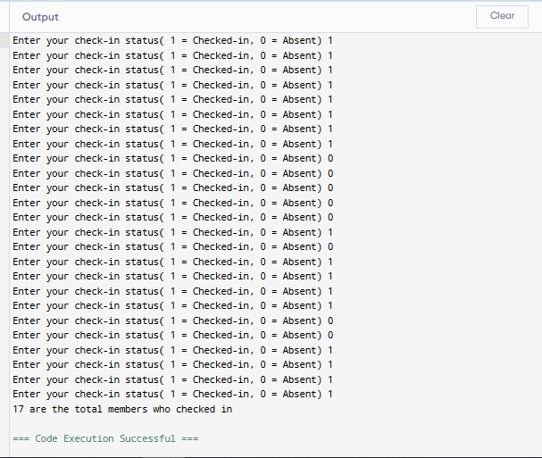
TASK: 02
#include <stdio.h>
int main() {
int balance = 1000;
int usage;

while(balance > 0){
printf("Enter data usage (MB): ");
scanf("%d", &usage);

balance = balance - usage;

printf("Remaining balance: %d MB\n", balance);
}

printf("Data balance finished.\n");

return 0;
}
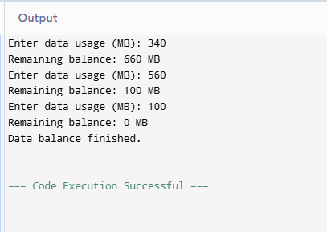
TASK: 03
#include <stdio.h>

int main() {
int code;

do{
printf("Enter access code: ");
scanf("%d", &code);

if(code != 2468){
printf("Incorrect code. Try again.\n");
}

}while(code != 2468);

printf("Door Unlocked!\n");

return 0;
}
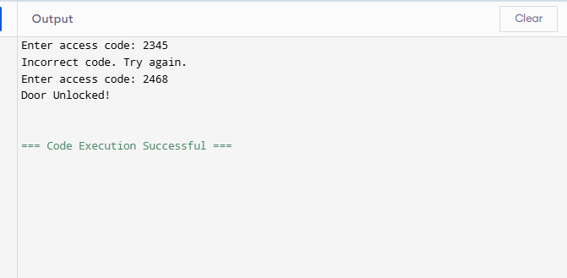
TASK: 04
#include <stdio.h>

int main() {
int N, total = 0;

printf("Enter number of days: ");
scanf("%d", &N);

for(int i = 1; i <= N; i++){
total = total + i;
}

printf("Total distance covered: %d km\n", total);

return 0;
}
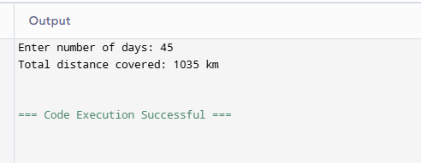
TASK: 05
#include <stdio.h>

int main() {
float salary;

printf("Enter base salary: ");
scanf("%f", &salary);

for(int i = 1; i <= 10; i++){
salary = salary + salary * 0.05;
printf("Year %d Salary: %.2f\n", i, salary);
}

return 0;
}
TASK: 06
#include <stdio.h>

int main() {
float salary;

printf("Enter base salary: ");
scanf("%f", &salary);

for(int i = 1; i <= 10; i++){
salary = salary + salary * 0.05;
printf("Year %d Salary: %.2f\n", i, salary);
}

return 0;
}
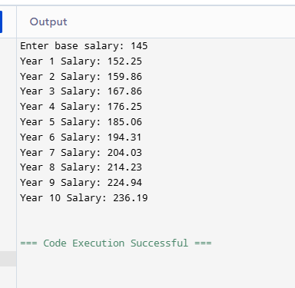
TASK: 07
#include <stdio.h>

int main() {
int choice;

do{
printf("\n1. Issue Book\n");
printf("2. Return Book\n");
printf("3. Exit\n");

printf("Enter choice: ");
scanf("%d", &choice);

if(choice == 1){
printf("Book Issued.\n");
}
else if(choice == 2){
printf("Book Returned.\n");
}

}while(choice != 3);

printf("Exiting system...\n");

return 0;
}
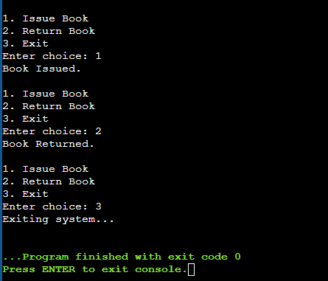
TASK: 08
#include <stdio.h>

int main() {
int pin;

printf("Enter PIN: ");
scanf("%d", &pin);

while(pin != 5555){
printf("Incorrect PIN\n");
printf("Enter PIN again: ");
scanf("%d", &pin);
}

printf("Access Granted\n");

return 0;
}
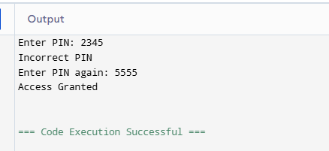
TASK: 09
#include <stdio.h>

int main() {
int N;
int total = 0;

printf("Enter number of tickets: ");
scanf("%d", &N);

for(int i = 1; i <= N; i++){
total = total + (i * 100);
}

printf("Total Revenue: $%d\n", total);

return 0;
}
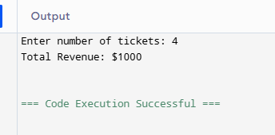
TASK:10
#include <stdio.h>

int main() {
int rating;
int excellent = 0, satisfactory = 0, improvement = 0;

printf("Enter rating (-1 to stop): ");
scanf("%d", &rating);

while(rating != -1){

if(rating >= 85){
excellent++;
}
else if(rating >= 60){
satisfactory++;
}
else{
improvement++;
}

printf("Enter rating (-1 to stop): ");
scanf("%d", &rating);
}

printf("Excellent: %d\n", excellent);
printf("Satisfactory: %d\n", satisfactory);
printf("Needs Improvement: %d\n", improvement);

return 0;
}
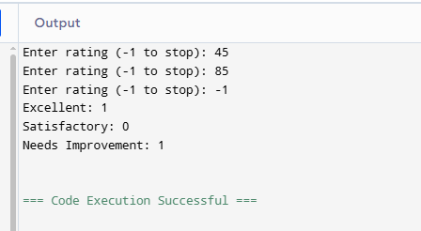
TASK: 11
#include <stdio.h>

int main() {
float price, total = 0;
int choice;

do{
printf("Enter item price: ");
scanf("%f", &price);

total = total + price;

printf("Add another item? (1=Yes, 0=No): ");
scanf("%d", &choice);

}while(choice == 1);

if(total > 3000){
total = total - total * 0.10;
}

printf("Final Bill: %.2f\n", total);

return 0;
}
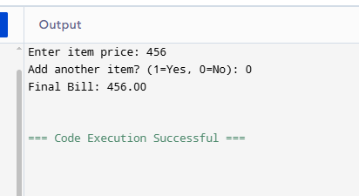
TASK: 12
#include <stdio.h>

int main() {
int spaces = 50;
int input = 1;

while(spaces > 0 && input != 0){

printf("Enter 1 for car arrival (0 to stop): ");
scanf("%d", &input);

if(input == 1){
spaces--;
printf("Remaining spaces: %d\n", spaces);
}
}

if(spaces == 0){
printf("Parking lot is full.\n");
}

return 0;
}
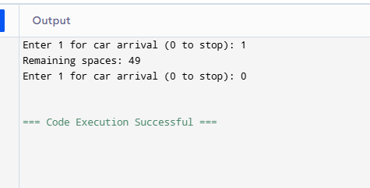
Git Hub Link:

